# Exporting Developers Notes

The issue exporting the Developers Notes is this:

I’m trying to export this structure:



And everything works except the content of the notes.

I manage to import the file with no problems using this structure:

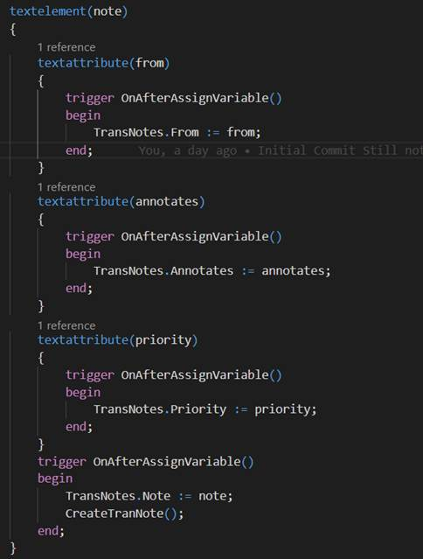

But I cannot do the same on the output.

I can get the notes like this:

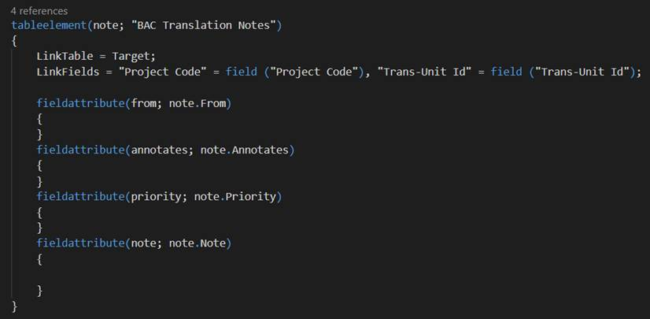

But I cannot get the content of note in any way possible.

Any help?

# General Translation Terms must be per language

Right now, the General Translations Terms are … General.

Too much. They should be General per language.